**Beam test of the silicon timing for use in calorimetry.**

Artur Apreysana, Adi Bornheima, Gino Bollab, Sergey Losb*, Cristian Penaa, Erik Rambergb,

Anatoly Ronzhinb, Maria Spiropulua, Si Xiea, Heejong Kimc

a*California Institute of Technology, 1200E California Blvd, Pasadena, CA91125, USA*

*bFermi National Accelerator Laboratory, P.O.Box500, Batavia, IL60510, USA*

*cUniversity of Chicago, Chicago, Il 60637, USA*

**Abstract**

The high luminosity upgrade of the Large Hadron Collider (HL-LHC) at CERN is expected to provide instantaneous luminosities of 5x 1034 cm-2 s-1. [1]. Collision at the high luminosity has shorter bunch spacing and more pileup [PU] events in the complex luminous regions [2]. Precision timing allows extend calorimetric measurements into high density environment. We performed some study of the possible options to improve timing for calorimetry [3-7]. CMS calorimetry upgrade based on silicon as sensitive layer is another upgrade option [8]. Signal response of silicon detectors could be about few ns with rise time of ~1 ns [9]. 8000 e-h pairs produced in silicon per 100 μm, which is much higher than silicon noise [10]. These properties with relatively high radiation hardness [11] allow to use silicon in calorimetric detectors [12]. In this article we present results of timing study of silicon produced by Hamamatsu [13]. The measurements performed performed at Fermilab Test Beam Facility (FTBF), [14].

**1. Introduction**

One way to mitigate the pileup confusion effects, complementary to precision tracking methods, is to perform a time of arrival measurement associated with a particular layer of the calorimeter, allowing for a time assignment for both charged particles and photons. Such a measurement with a precision of about 20–30 ps, when unambiguously associated to the corresponding energy measurement, will significantly reduce the inclusion of pileup particles in the reconstruction of the event of interest, given that the spread in collision time of the pileup interactions is approximately 200 ps. The association of the time measurement with the energy measurement is crucial, and leads to a prototype design that calls for the time and energy measurements to be performed in the same active detector element. It is in this context that we studied the possibility of measuring the time of arrival of the particles with a calorimetric device when using silicon as sensitive element.

The paper is organized as follows. The general silicon timing properties are described and bench test results of the used silicon described in section 2. Special attention is taken to the main source of the time jitter in silicon. Test beam setup and results of the silicon test presented in sections 3. Section 4 and 5 devoted to discussion and conclusion, respectively.

**2. Silicon timing. Bench test of used silicon**

Few factors determine the timing response of silicon detectors. One of them defines time constant and depends on series resistance of the silicon, load resistance and terminal capacitance. The other are due to silicon intrinsic properties: the silicon thickness, the carrier’s velocity and its collection time, dependent on depletion voltage and type of the carriers. The carriers drift time in fully depleted silicon determines the carrier’s collection time. This time determines the silicon time response in case of small time constant, but the response could be mostly dependent on time constant for silicon with large capacitance.

We used for our test the silicon, produced by Hamamatsu [13]. The thickness of the silicon is ~325 um. The transverse size of the silicon is 6x6 mm2. The negative bias voltage was applied to p-side of the silicon. The dependence of the diode capacitance on the bias voltage is presented in Fig. 1. The junction capacitance depends on the area of p-layer and the thickness of the depletion layer which increased with inverse bias voltage. When charged particle pass through the silicon the produced electrons collected on the opposite (to p-side) n-side of the silicon and forms the output signal. The electrical schematics of the silicon diode and capacitance dependence on bias voltage presented in Fig.1 a, b.

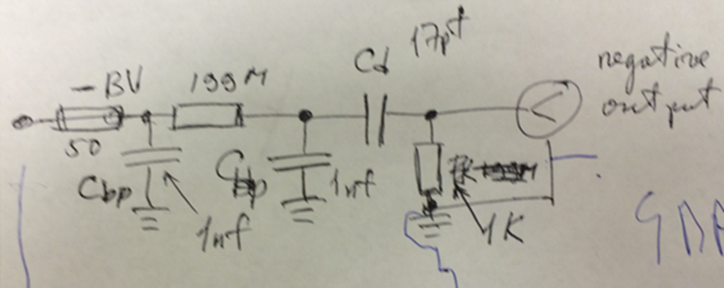 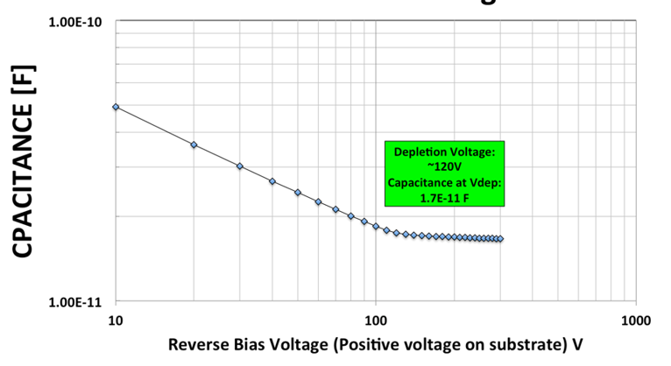

Fig.1 a, b. Electrical schematics of the silicon diode (left) and it capacitance in dependence on bias voltage (right).

The silicon box and bench test setup presented in Fig. 2 a, b. Measurements were performed at SiDet facility of Fermilab. The sensitivity of the silicon diode to light was tested to check it functionality.

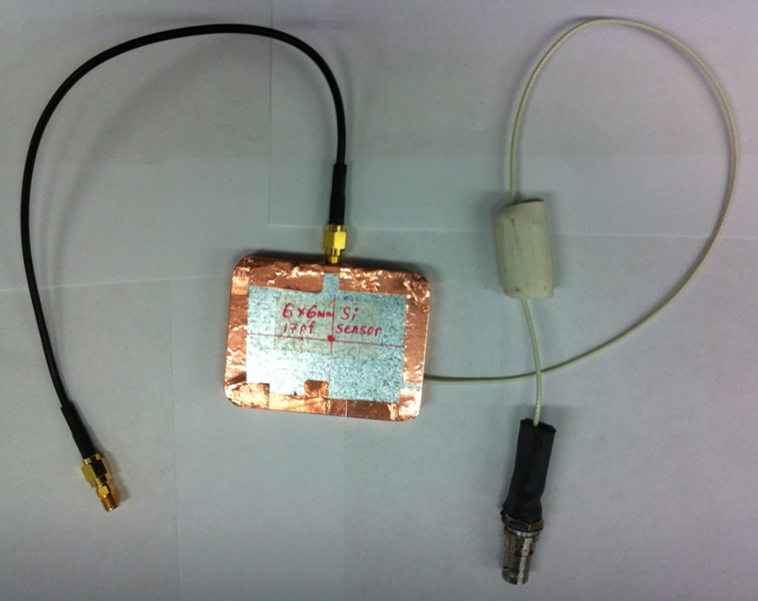 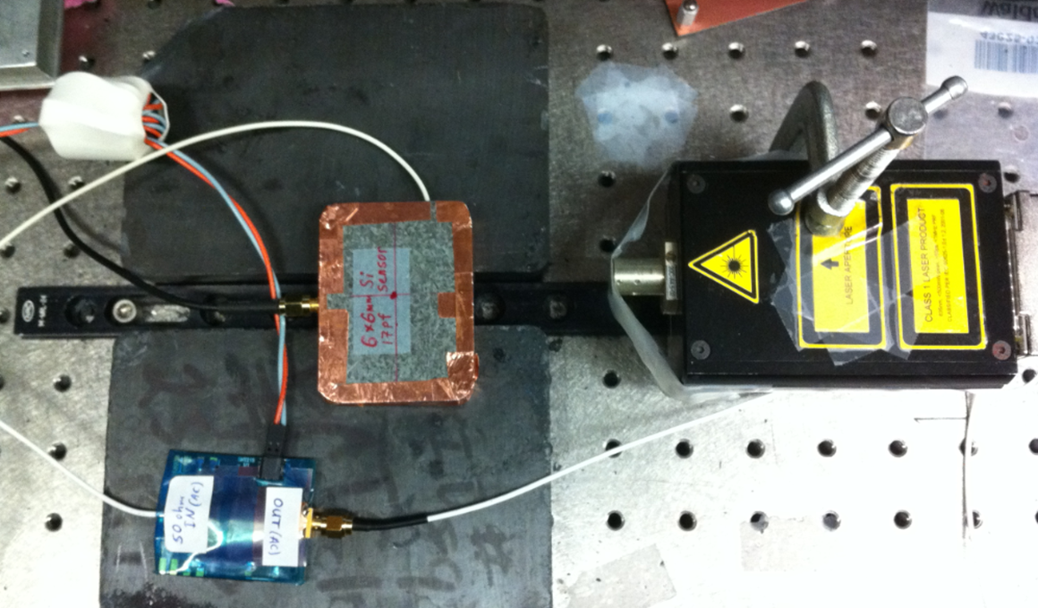

Fig. 2 a, b. External view of the box with silicon diode and PC board inside (left) and bench test setup (right).

The silicon diode was placed in the metal box. The HV was applied to the PC board by the cable terminated by HSV connector. The silicon diode output signal was taken out by using the SMA connector attached to the box. Dark current dependence on bias voltage was tested. The maximum value of the current at -500 V of the bias was less of 1nA. (we had not in hands picoampermeter to measure the current).

**3. Test beam setup and results of the silicon test**

The test beam measurements were performed in FTBF [14]. The main parts of the setup are well described in [5, 6, 7]. For the measurement with silicon it was slightly modified (Fig. 3).

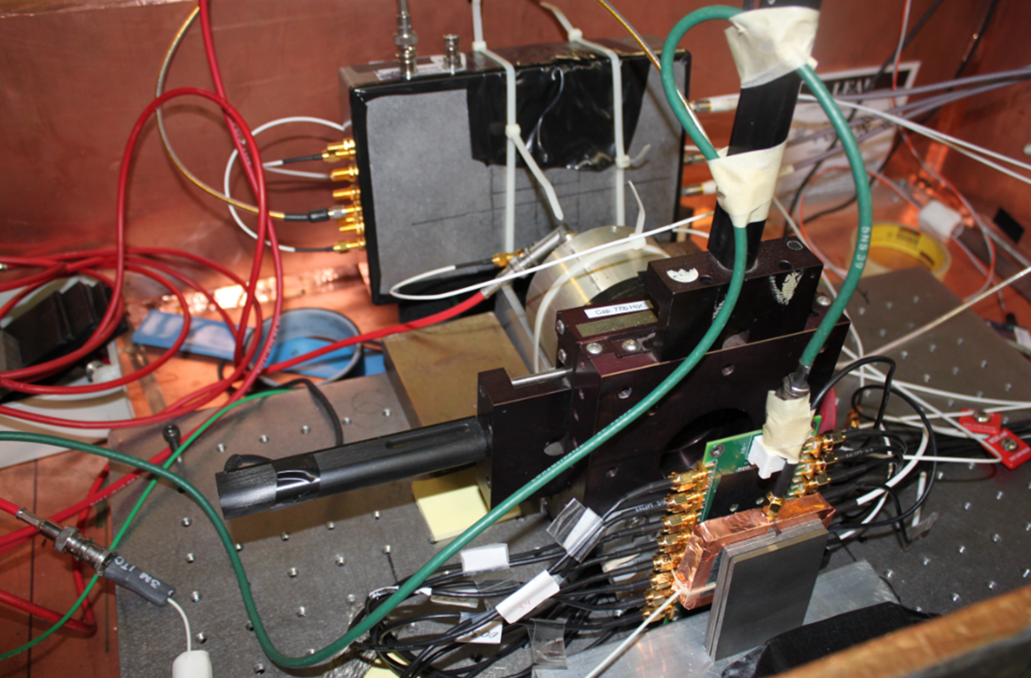

Fig. 3. Test beam setup.

The test beam setup is shown in Fig. 3. The silicon detector was placed inside of the metal box. The absorber (W or Pb) was placed upstream for measurements with electron beam. We have not used absorber in measurements with 120 GeV protons. Other detectors which shown in the Fig. 3 were tested simultaneously.

The setup contains a data acquisition (DAQ) system based on CAEN V1742 5 Gs/s digitizer [15], HV power supplies, and equipment to monitor and control test beam parameters. The dark box was located on a moving table allowing us to change the box position both in the horizontal and vertical direction in the range of 300 mm in X and Y with an accuracy better than 0.5 mm. Event selection and analysis was described in detail in [5]. The trigger was based on a scintillation counter with 1.8 x 2 mm2 transverse size. The three detectors (4x4 Hamamatsu MPPC matrix [16], Photek 240 timing reference MCP-PMT and 6x6 cm2 LAPD [17]) were placed in line downstream of the tested silicon. The silicon detector was positioned on an X–Y moving stage, which allowed movement in both X and Y directions by +/-15mm. The stage was operated remotely from the test beam control room. It was possible to align the silicon detector with ~10 μm accuracy in both X and Y directions.

The tungsten absorber material was used to initiate an electromagnetic shower when high energy electrons pass through. Signals from the detectors and the Cherenkov counter used for electron identification were split by high frequency Mini-Circuits  ZFRSC-42-S þ splitters (4.2 GHz BW). The outputs were connected to CAEN V1742 digitizer, which allowed to hook up 32 channels for the measurements. The schematic of the similar readout (with DRS4) is described in detail in [5-7].

An example of a first silicon signal detected is shown in Fig. 4.

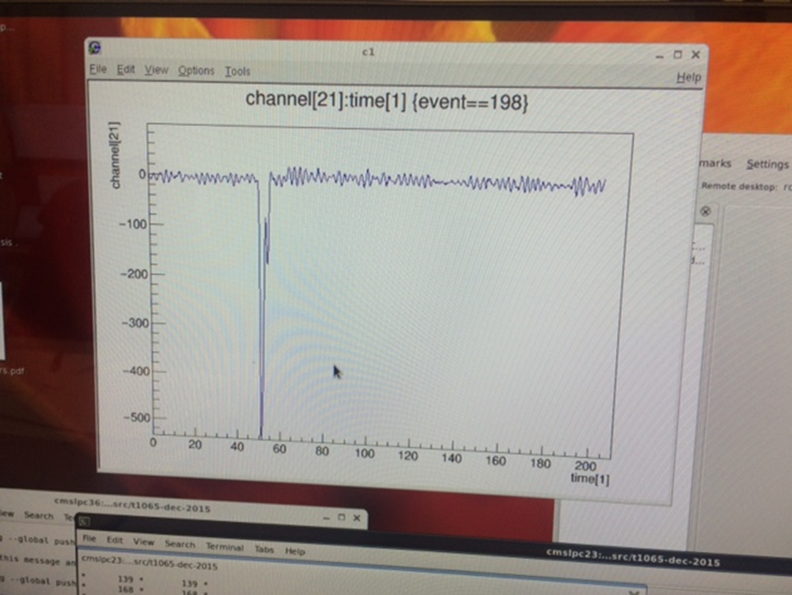

Fig. 4. Silicon signal. Conditions: 8 GeV electrons, 4 X0 of W upstream of silicon, bias voltage = -500 V, Ortec VT120C [18] + Hamamatsu [19] in series with silicon output signal.

Some ripples are seen before and after the signal, which are due to pickup noise which was later suppressed by improved schematics.

We can see large signal amplitude in the Fig. 4. The gain of the silicon detector with the amplifiers was in excess of 106. Placement of absorbers in front of the silicon also increased the signal size due to increased particle flux from secondary shower particles. We measured the “electronic” time resolution (TR) of the whole used chain taking into account the new calibration procedure [20]. The electronic time resolution was ~4ps. We neglected this impact on the timing measurements described below.

Most of the measurements were performed with an 8 GeV/c secondary beam because it provides a high purity electron beam, as well as to allow comparisons with our previous measurements. The stack of tungsten plates with different thicknesses was placed close to the silicon unit. The transverse size of the tungsten plates allowed us to fully cover the transverse size of the unit. For measurements with the secondary beams, we selected electron events with a gas Cherenkov counter that is part of the equipment provided by the FTBF. The fraction of the electrons in the 8 GeV secondary beam was 50%. The silicon signal sample detected by V1742 digitizer is shown in Fig. 5.

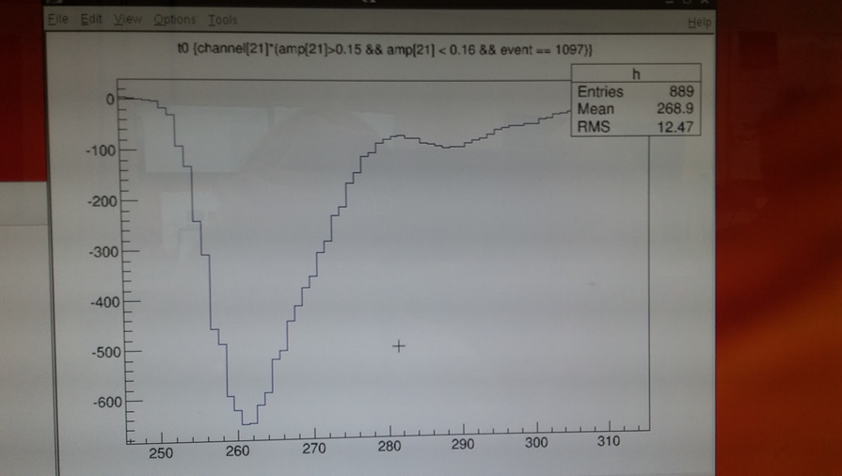

Fig. 5. Example of silicon signal taken by CAEN V1742 digitizer.

The noise distribution of the silicon presented in Fig. 6.

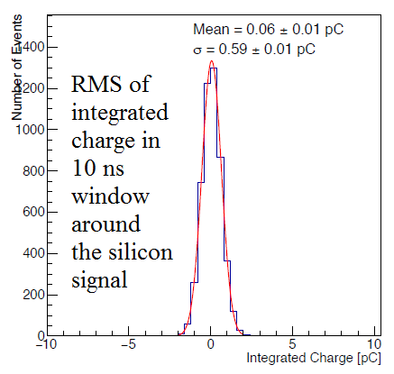

Fig. 6. Silicon noise approximated by Gaussian distribution. The trigger in the measurements was pulse generator.

Measured pulse height (PH) distribution for 120 GeV proton presented in Fig. 7.

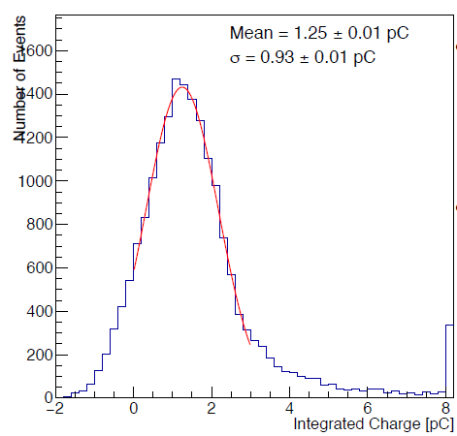

Fig. 7. Pulse height distribution for 120 GeV proton.

We can estimate the amplitude of the silicon signal for 120 GeV proton. The amount of electron produced is ~30000 in 300 um silicon. The gain of used amplifiers (2 Ortec 120V in series) is 200. The total gain of the circuit is 6x106 electrons. The corresponding charge is 1 pC/proton. Taking into account the pulse duration (which is ~5ns), external load 50 Ohm and factor of 2 for triangular signal shape we obtain 20 mV/proton the silicon signal amplitude. This estimation consistent with the measurement.

Pulse height distribution for 4 GeV electrons presented in Fig. 8.

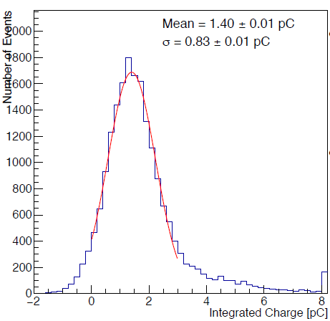

Fig. 8. Pulse height distribution for 4 GeV electrons.

The shape of the distribution looks pretty similar to 120 GeV proton. The mean value is ~11% larger.

In the Fig. 9 presented measured silicon PH distribution in dependence on 4, 8, 16 and 32 GeV electron beam energy. 6 Xo radiation length of tungsten used in all measurements.

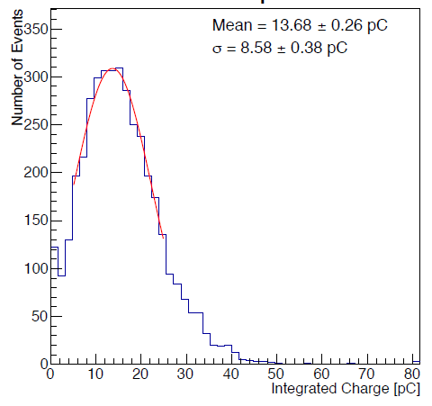 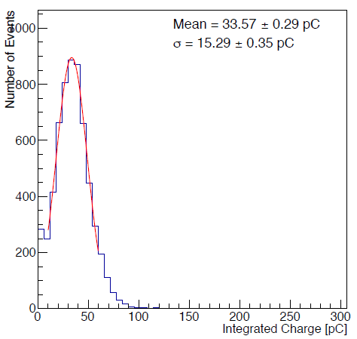

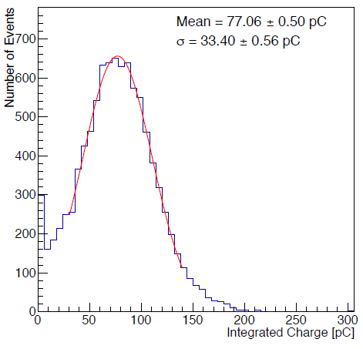 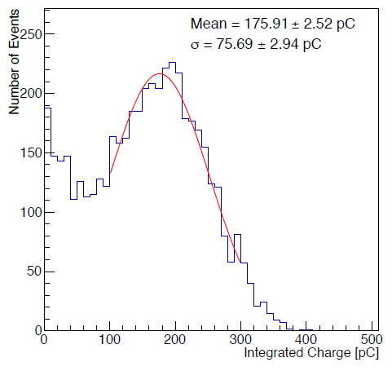

Fig. 9. Measured silicon PH distribution in dependence on 4, 8, 16 and 32 GeV electron beam energy.

The dependences of the integrated charge vs electron energy in the range 4-32 GeV is shown in Fig. 10.

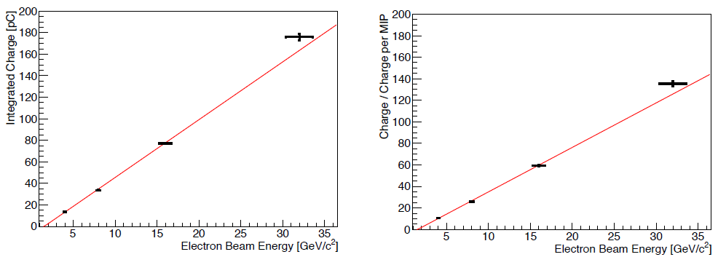

Fig. 10. The dependences of the integrated charge vs electron energy in the range 4-32 GeV.

In the Fig. 11 is shown longitudinal shower profile measured for 8 GeV electrons, left. On the right presented the profile measured earlier […] with MCP Photonis in the same other conditions.

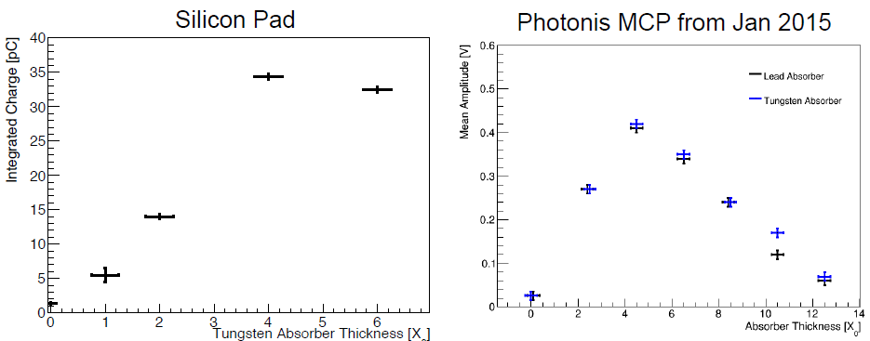

Fig. 11. The amplitude of the silicon signal in dependence on the absorber (W) thickness, left. The result of the same measurement performed earlier with Photonis MCP, right […].

The dependence of the integrated silicon charge and the charge normalized to 120 GeV proton vs applied bias voltage is shown in Fig. 12.

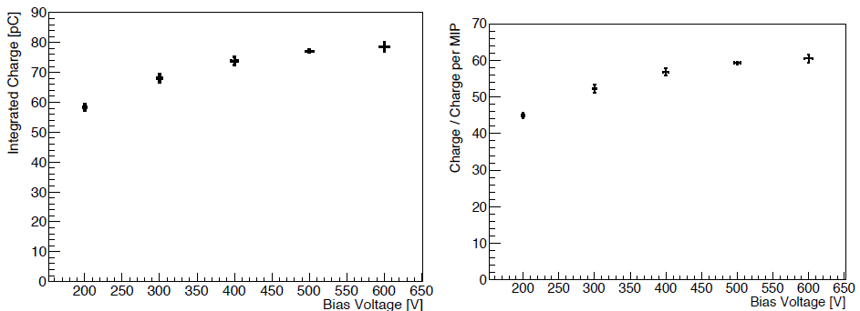

Fig. 12. The dependence of the integrated silicon charge and the charge normalized to 120 GeV proton vs applied bias voltage. 8 GeV electrons, 6 Xo of tungsten.

In the Fig. 13 is shown simulated, (left) and measured (right) silicon time resolution, in dependence on the beam energy.

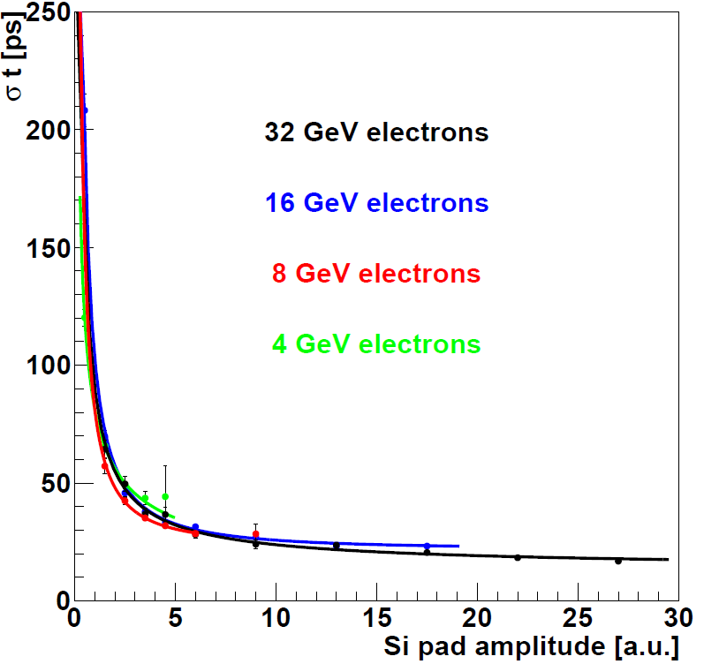 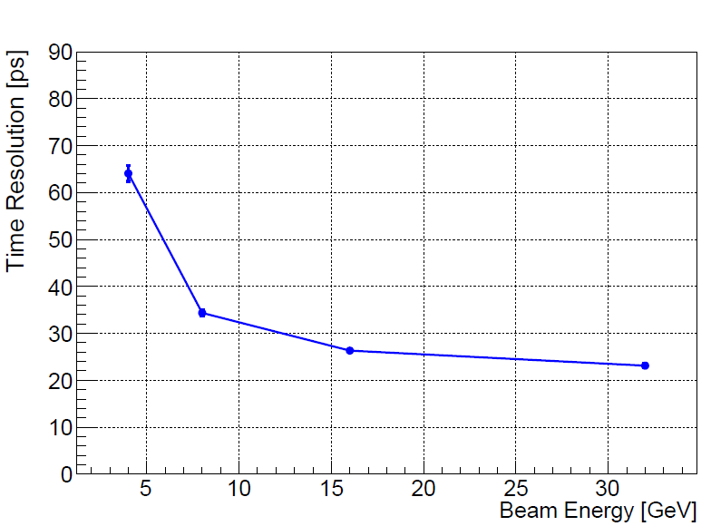

Fig. 13. Simulated, (left) and measured (right) silicon time resolution in dependence on the beam energy.

The best time resolution result, obtained with the silicon is ~23 ps.

**4. Discussion**

Electric field applied to silicon results in the built-in junction voltage (~0.6V) which is typical of silicon diodes. The high electric field in silicon leads to total depletion which is formed from a conducting region by removal of all free charge carriers. When charged particle pass through the totally depleted silicon region it produces carriers collecting on corresponding electrodes and producing output signal. Suppose the thickness of the silicon is 100 um. The relativistic particle pass the 100 um by 0.3 ps, so we can neglect this time (and jitter) in the consideration. The electrons produced by the particle collected on positive electrode and the holes on the negative. At high fields E > 105 V/cm the mobility of carriers attain a constant drift velocity of 108 mm/s (1um/10ps) in the silicon [21]. The amount of electrons produced in the 100 um is ~10000 (let’s take this value instead of 8000 for simplicity). The time needed to collect all electrons in the 100 um is ~1ns.

The electrons produced closer to the positive electrode collected first. The time needed to pass 1 um by electron is ~10 ps. The average time between the electrons is ~1 ps. If electronic can detect 100 electrons its arrival time could be inside of the 10 ps. The time jitter could be estimated as 3 ps for Poisson timing distribution. For example, if electronics can detects ~100 electrons (with additional amplification) produced in silicon they collected from the thickness of ~10 um. We can say that the “rest of the silicon thickness” does not participate in the silicon time jitter, because these electrons are coming “too late”. This simple model can explain in general obtained test beam results.

The obtained data are in good consistency with calculation. The noise of the silicon with performed schematics is pretty low. It allows to detects the 120 GeV proton and 4 GeV electron (w/o absorber) with high efficiency, which could be estimated as >80% (Figs. 6-8). The detected charge shows linear dependence on absorber length. (Figs. 9, 10). The longitudinal shower profile performed with the silicon is in good consistency with previous result obtained with MCP. The integrated silicon charge in dependence on Bias voltage show saturation at ~500V for used silicon. This is ~ 150 V less of maximum voltage that could be applied to the silicon. The measured and calculated time resolution for the silicon are in good consistency (Fig. 13).

**5. Conclusion**

We obtained time resolution for the silicon ~23 ps. This could correspond to ~137 particle registered in the shower. The 120 GeV proton amplitude corresponds to ~20 mV according to measurements and estimation. We see significant amplitude increase when absorber used. This open an opportunity to use the silicon as active layer in calorimeter, for example in CMS HGC upgrade [22]. We can consider the results of this work as good opportunity to use silicon for timing measurements in future calorimeter. We plan to perform optimization of the possible silicon version, e.g. transverse size and configuration for multipixel readout, etc. This will be aim of our next work.

**Acknowledgement**

We thank FTBF personnel for very good beam condition during our test run. We also appreciate technical support of Fermilab SiDet department for production of high quality silicon samples. We appreciate Helmuth Spieler monography as a good source of silicon information [23].

**References**

1. CMS Collaboration, ”Projected Performance of an Upgraded CMS Detector at the LHC and HL-LHC: Contribution to the Snowmass Process”, 26 July 2013, arXiv:1307.7135[hep-ex].

2. D. Contardo, J. Spalding, CMS Phase2 Upgrade: Preliminary Plan and Cost Estimate, Technical Report, CERN-RRB-2013-124, CERN, Geneva, October 2013.

3. Dustin Anderson, Artur Apreysan, Adi Bornheim, Javier Duarte, Harvey Newman, Cristian Pena, Anatoly Ronzhin, Maria Spiropulu, Jason Trevor, Si Xie, Ren-Yuan Zhu. “Precision timing measurements for high energy photons”. Nuclear Instruments and Methods in Physics Research A787 (2015) 94–97.

4. D. Anderson, A. Apresyan, A. Bornheim, J. Duarte, C. Pena, A. Ronzhin, M. Spiropulu, J.Trevor , S.Xie a “On timing properties of LYSO-based calorimeters”. Nuclear Instruments and Methods in Physics Research, A794 (2015) 7–14.

5. A. Ronzhin, S. Los, E. Ramberg, M. Spiropulu, A. Apresyan, S. Xie, H. Kim, A. Zatserklyaniy “Development of a new fast shower maximum detector based on microchannel plates photomultipliers (MCP-PMT) as an active element”. Nuclear Instruments and Methods in Physics Research A759 (2014) 65–73.

6. A. Ronzhin, S. Los, E. Ramberg, A. Apresyan, S. Xie, M. Spiropulu, H. Kim. “Study of the timing performance of micro-channel plate photomultiplier for use as an active layer in a shower maximum detector”, Nuclear Instruments and Methods in Physics Research, A795 (2015) 288–292.

7. A. Ronzhin, S. Los, E. Ramberg, A. Apresyan, S. Xie, M. Spiropulu, H. Kim. “Direct tests of microchannel plates as the active element of a new Shower maximum detector”, Nuclear Instruments and Methods in Physics CMS

8. Nadia Pastrone, “CMS upgrade perspectives” report at ICHEP, Valencia, July 3, 2014

9. P. Meridiani on behalf of the HGC Fast Timing TB group. Results for July 2015 fast timing tb. 08/09/2015, report.

10. Lutz Feld, “The CMS All Silicon Tracker A Detector for the Exploration of the Terascale” Physikalisches Institut, RWTH Aachen Heidelberg, 23. 3. 2007

11. D. Barney et al. “Measurement of the bulk leakage current of silicon sensors of the CMS preshower detector after an integrated luminosity of 6.17 fb-1 at sqrt(s) = 7 TeV”. J. Inst. 8 P02004, 2013.

12. J. C. Brient, Improving the jet reconstruction with the particle flow method: An introduction, Prepared for 11th International Conference on Calorimetry in High-Energy Physics (Calor 2004), Perugia, Italy, 28 March - 2 April 2004. CALICE calorimetry, electromagnetic part.

13. Si detectors for high energy particles, chapter 10. https://www.hamamatsu.com/resources/pdf/ssd/e10_handbook_for_high_energy.pdf

14. FTBF, <http://ftbf.fnal.gov/>

15. CAEN V1742 digitizer. http://www.caen.it/csite/CaenProd.jsp?parent=11&idmod=661

16. Hamamatsu 4x4 MPPC matrix. http://www.caen.it/csite/CaenProd.jsp?parent=11&idmod=661

17. Jingbo Wang, “Performance of 6x6 cm2 Photo-detectors”, Internal LAPPD Review – 10/21/2014 https://indico.hep.anl.gov/indico/getFile.py/access?contribId=3&resId=0&materialId=slides&confId=450

18. Ortec VT120C fast preamplifier. www.ortec-online.com

19. Hamamatsu high speed amplifier C5594. http://www.hamamatsu.com/resources/pdf/etd/C5594_TACC1004E.pdf

20. H. Kim et al., “A new time calibration method for switched-capacitor-array-based on waveform samplers”. NIM, A767 (2014) pp. 67–74.

21. Anatoly Ronzhin. “High time-resolution photodetectors for PET applications”. Nuclear Instruments & Methods in Physics Research A(2015), http://dx.doi.org/10.1016/j.nima.2015.11.069i

22. R. Rusak. “Challenges and synergies of silicon sensor for a high granularity calorimetry”. http://indico.cern.ch/event/346103/session/0/contribution/4/attachments/682273/937287/HGC-Silicon-ECFA-Draft2.pdf

23. Helmuth Spieler: Semiconductor Detector Systems, Oxford University Press, 2005.